Account creation:

Go to <https://portal.azure.com/> Create your account

Now go to [www.microsoftazurepass.com](http://www.microsoftazurepass.com) and after login apply coupon code

You can check your balance under subscription

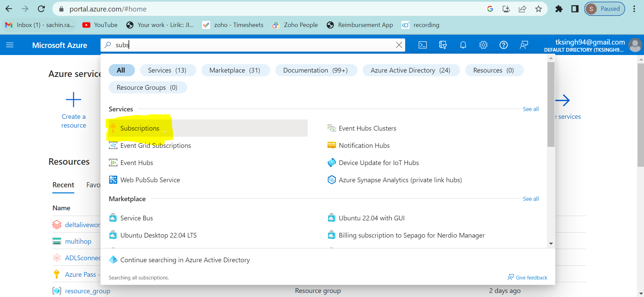

Storage account creation

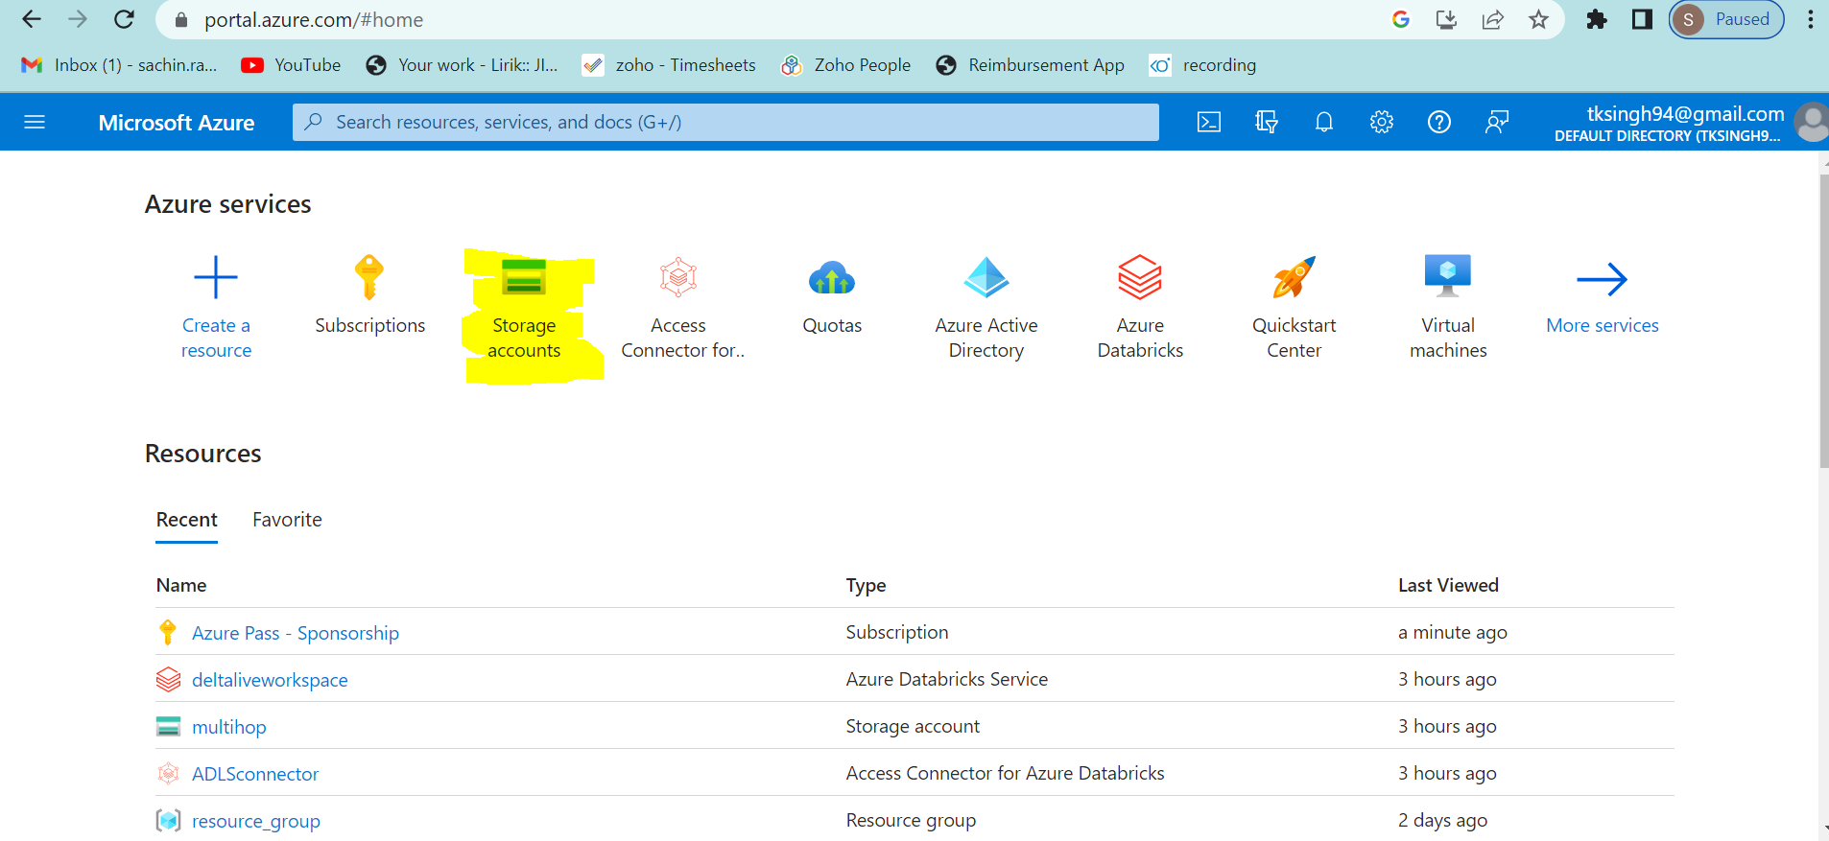

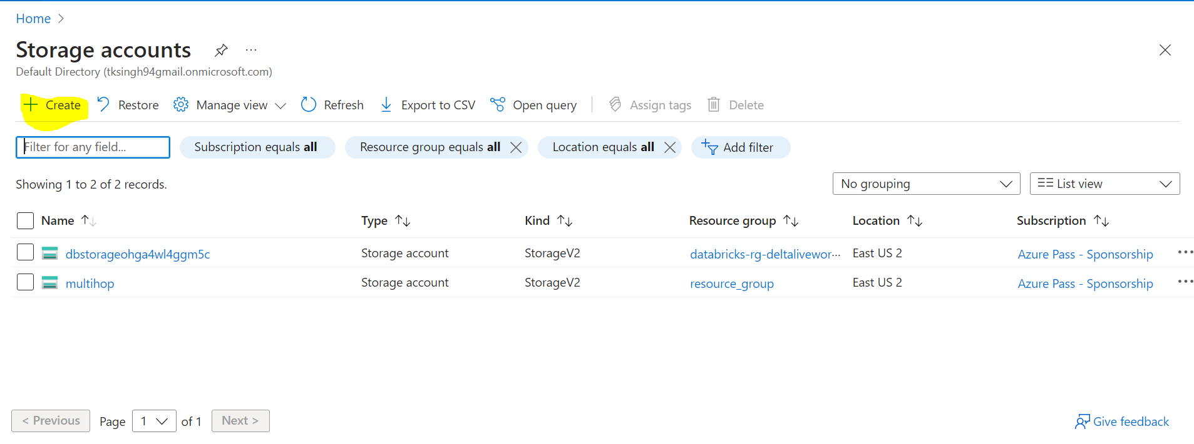

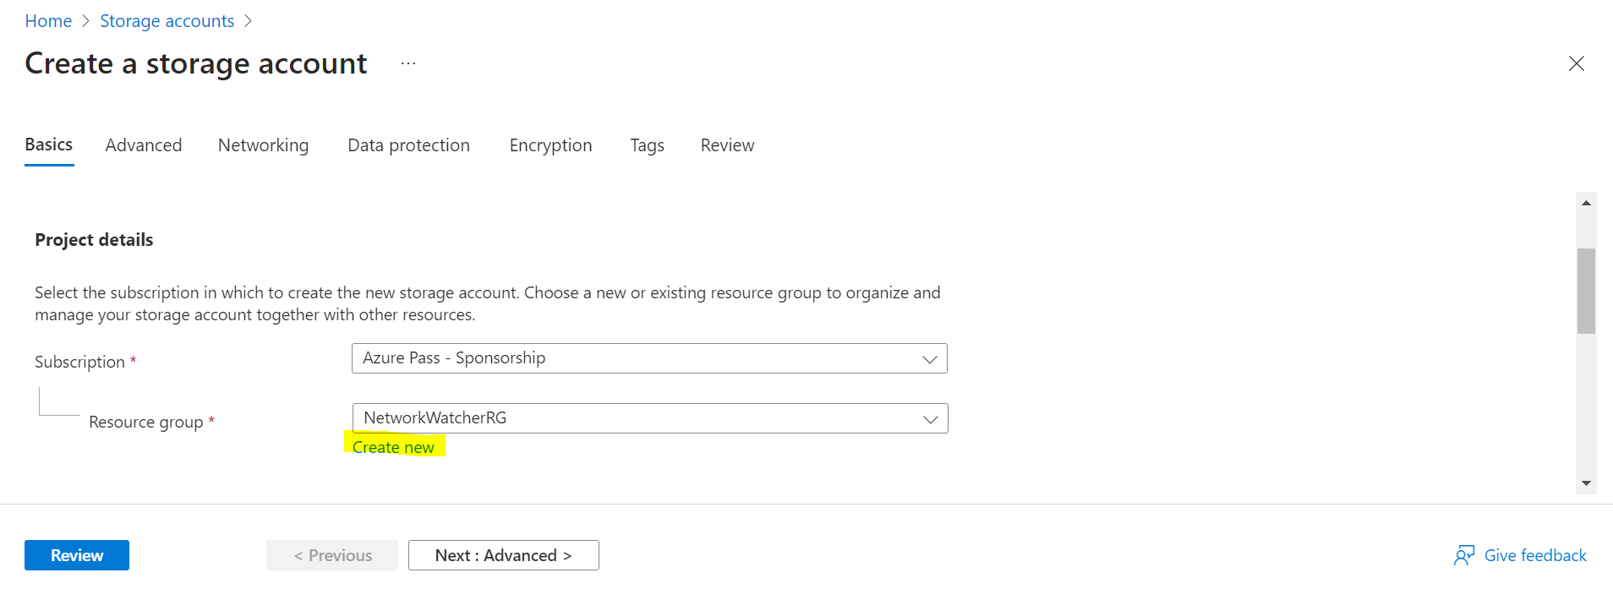

After few minutes your storage will be created , after this go to created storage and create a container in it

Container creation

Inside container you can creation directories and upload files

Create workspace

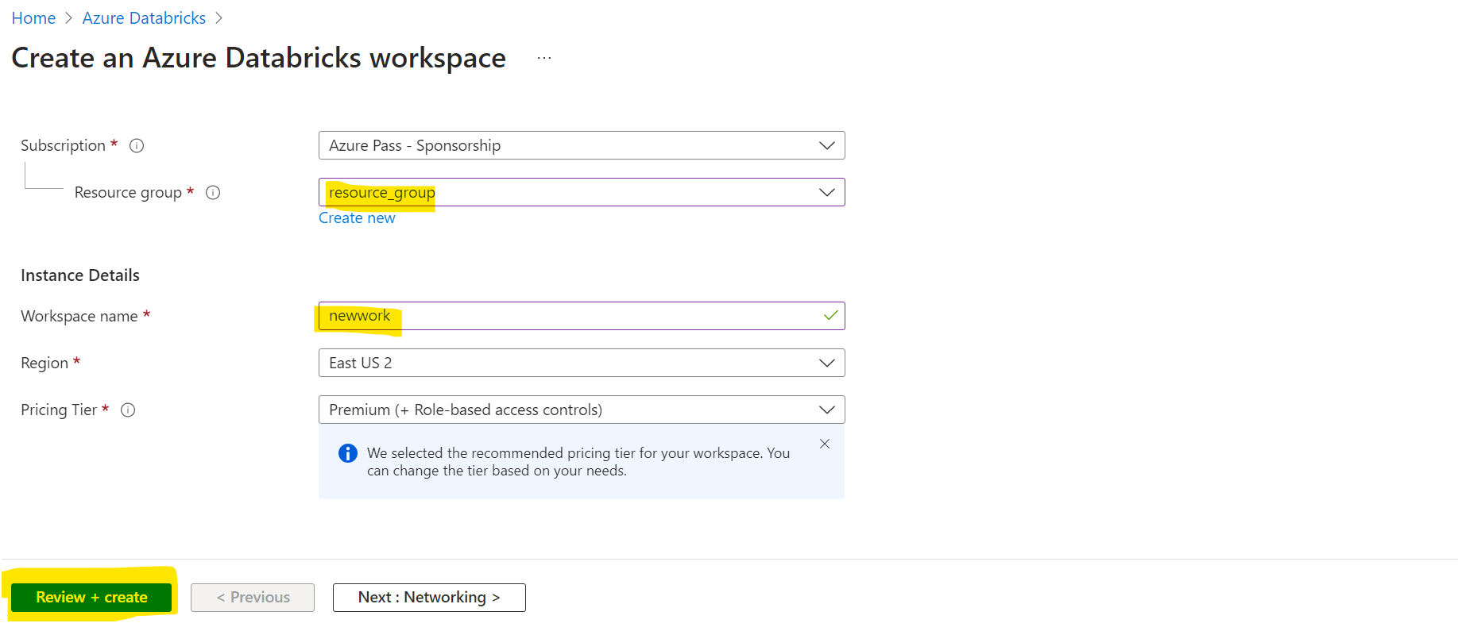

After creation go the workspace and launch it

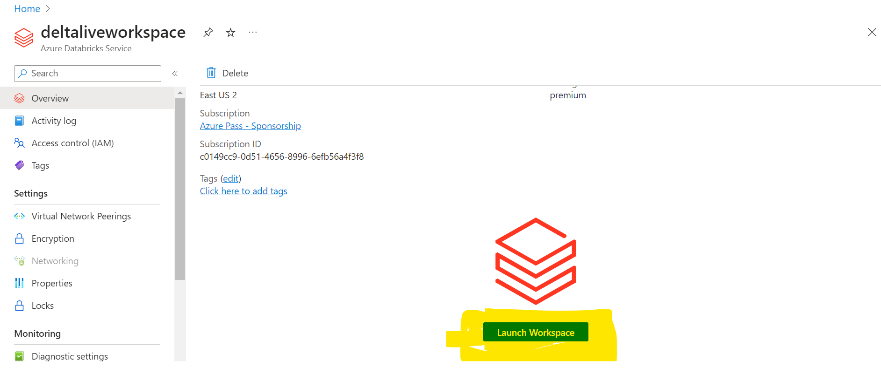

After going inside the workspace go to compute and create a cluster

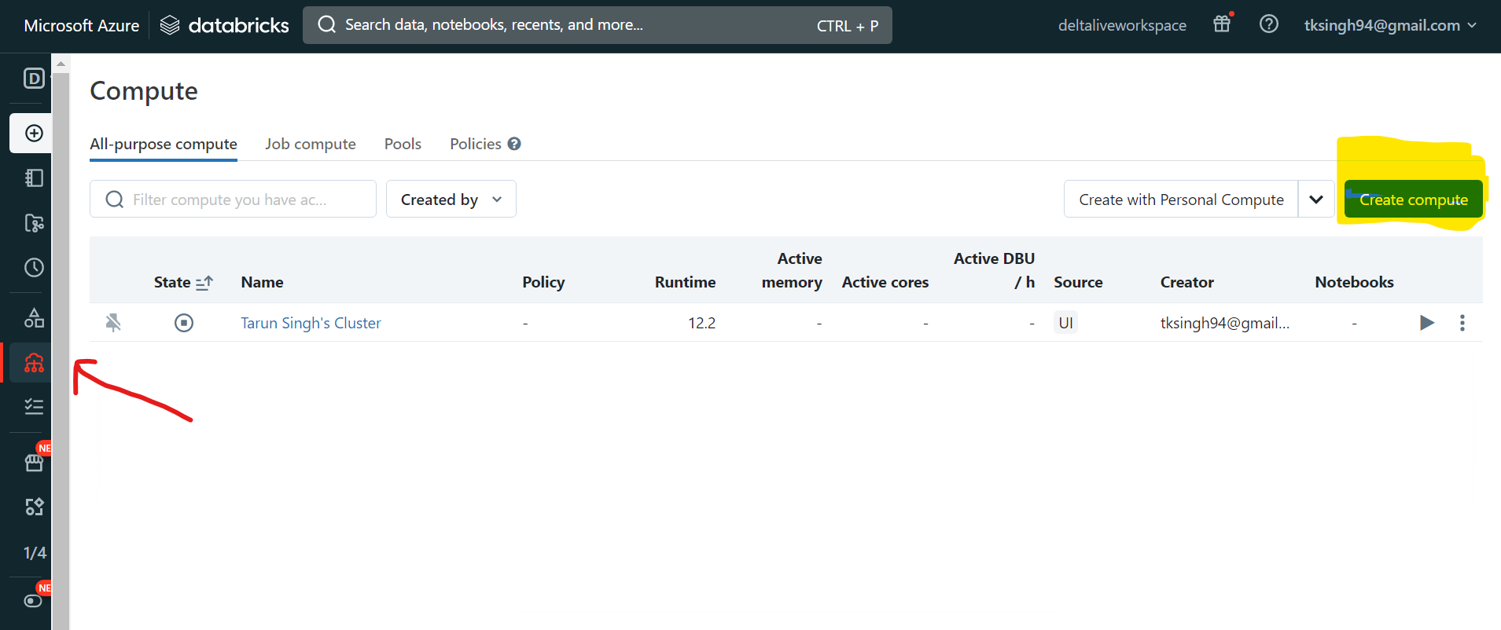

For creating a cluster select single node and set default termination time to 10 mins.

Granting Permission to files

To access the file in Databricks Workspace we need to provide permission to files. Below are the steps for it.

IMPORTANT:

Copy and save the secret key and value after certificate creation because after that you won’t be able to see them.

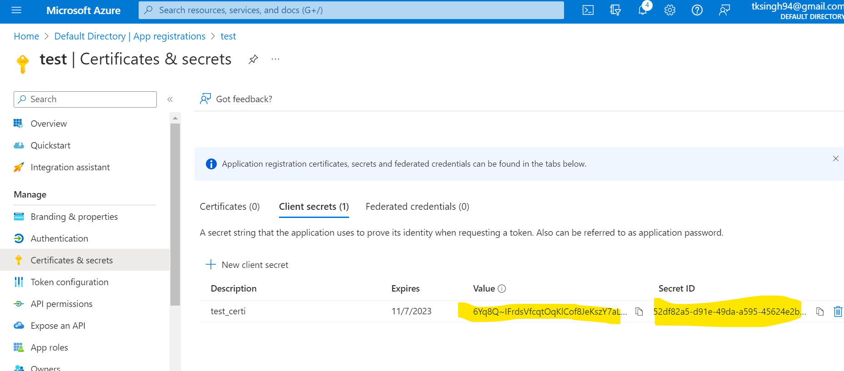

Giving I AM ROLE to containers

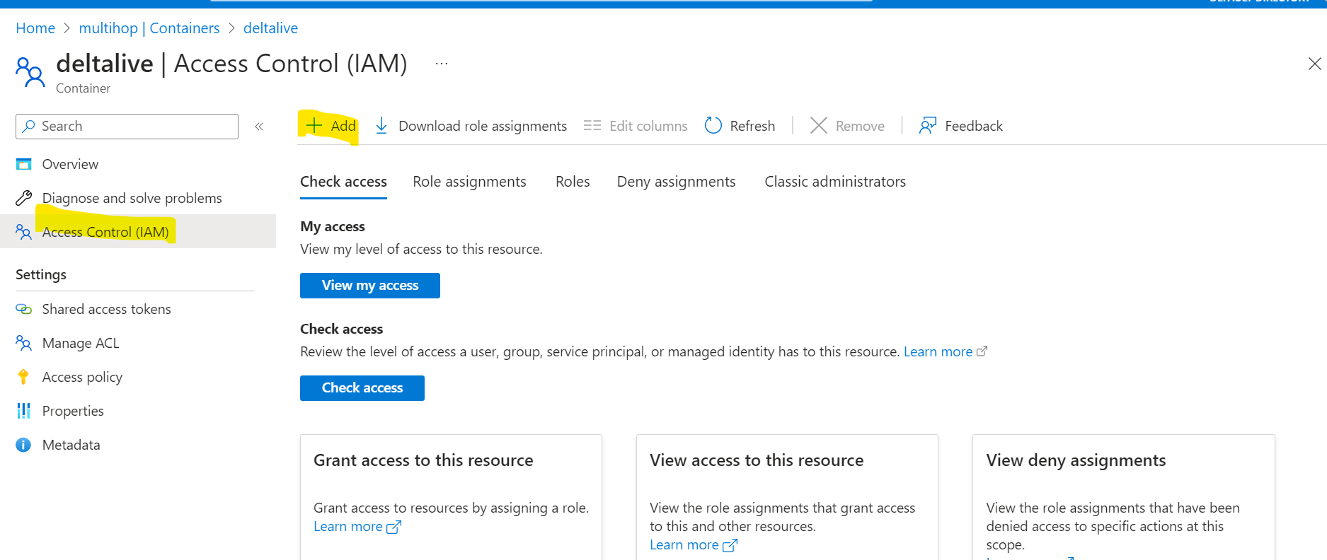

Mount creation

Create a mount in databricks workspace’s notebook

You can create mount using below lines of code

configs = {"fs.azure.account.auth.type": "OAuth",

"fs.azure.account.oauth.provider.type": "org.apache.hadoop.fs.azurebfs.oauth2.ClientCredsTokenProvider",

"fs.azure.account.oauth2.client.id": "<application-id>",

"fs.azure.account.oauth2.client.secret": dbutils.secrets.get(scope="<scope-name>",key="<service-credential-key-name>"),

"fs.azure.account.oauth2.client.endpoint": "https://login.microsoftonline.com/<directory-id>/oauth2/token"}

# Optionally, you can add <directory-name> to the source URI of your mount point.

dbutils.fs.mount(

source = "abfss://<container-name>@<storage-account-name>.dfs.core.windows.net/",

mount_point = "/mnt/<mount-name>",

extra_configs = configs)

Creating a DLT Pipeline

You can create DLT in databricks workspace inside workflow

Go to delta live table section

And then create the pipeline as follows:

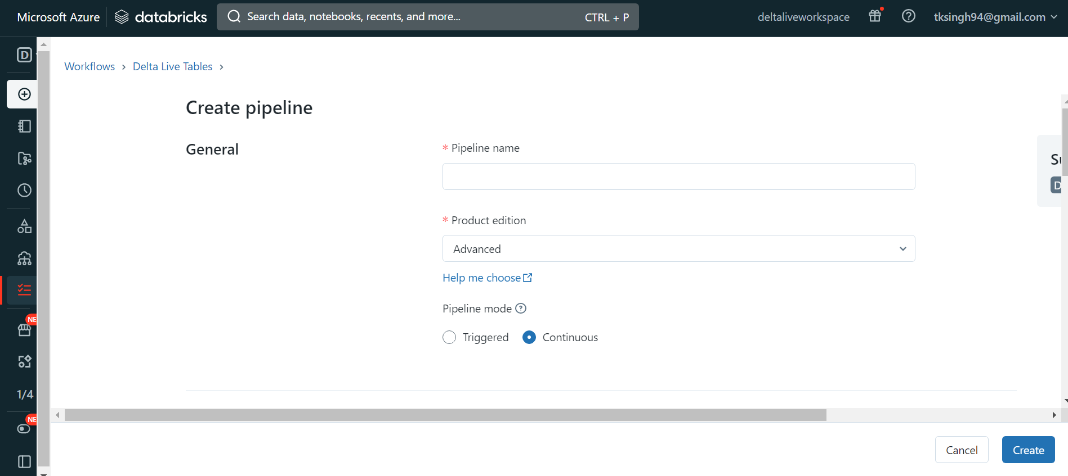

Now the select the notebook where you have your code

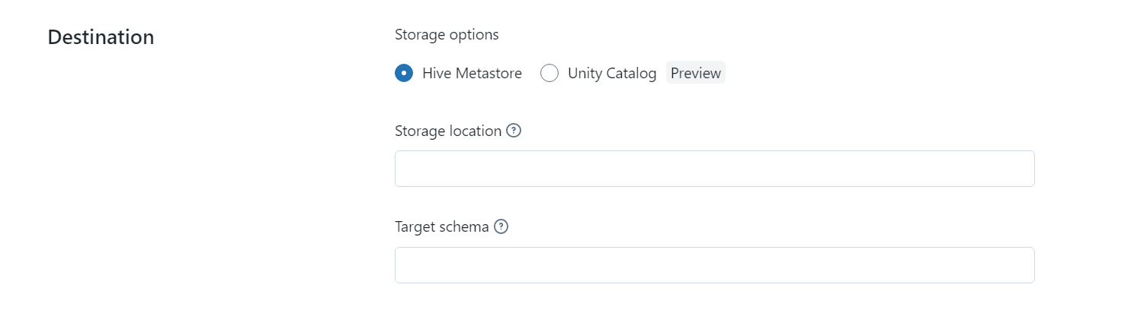

Give the Name of target schema/database (database will get created if not exist

